
Fall Semester 2025-26
Python Programming Lab Manual
Submitted for
Introduction to Problem Solving and Programming(CSE1021)

Name | Registration Number | Remarks
Himanshu Rathore | 25BCE10344 | ......

Course Instructor : Dr. Shahana Gajala Qureshi
VIT Bhopal University
Bhopal - Indore Highway
Kothri Kalan, Sehore -466114 Madhya Pradesh

Experiment 1: Variables, Expressions & Statements
- Aim :
Write a program to calculate the area and perimeter of a rectangle using variables and expressions.
- Algorithm / Pseudocode :
- Read length L and breadth B from user.
- Compute area = L * B.
- Compute perimeter = 2 * (L + B).
- Print area and perimeter.
- Python Code :
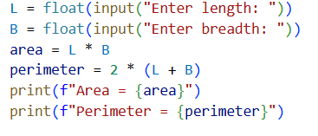
- Output :
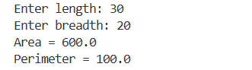

Experiment 2: Tuple Assignment & Operator Precedence
- Aim :
Demonstrate tuple assignment and precedence of operators in Python.
- Algorithm / Pseudocode :
- Assign a,b,c = 5,10,15.
- Compute x = 5 + 3 * 2 (operator precedence).
- Compute y = (5 + 3) * 2.
- Print values and explanations.
- Python Code :
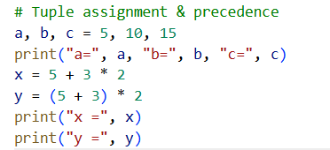
- Output :
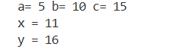

Experiment 3: Comments, Modules & Built-in Functions
- Aim :
Use comments and import Math module functions.
- Algorithm / Pseudocode :
- Import math.
- Read a number n.
- Compute sqrt, pow(n, p), ceil(n), floor(n).
- Show results with comments in code.
- Python Code :
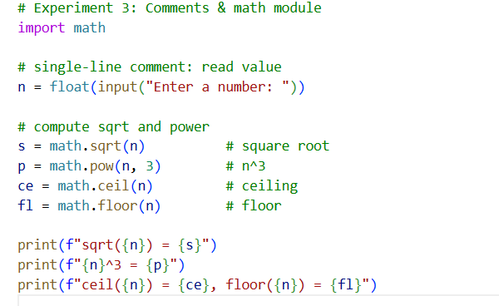
- Output :
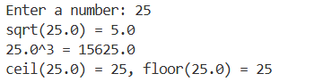

Experiment 4: Counting, Summation & Factorial Using Loops
- Aim :
To implement basic counting algorithms using loops.
- Algorithm / Pseudocode :
- Read N.
- Loop 1..N to print numbers.
- Sum via loop.
- Compute factorial with for.
- Compute factorial with while.
- Python Code :
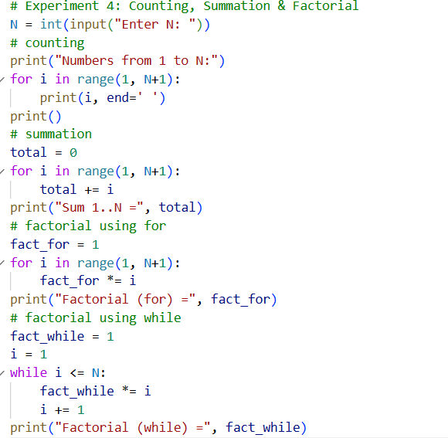

- Output :
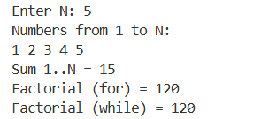

Experiment 5: Fibonacci Sequence Generation
- Aim :
To generate the Fibonacci sequence up to N terms.
- Algorithm / Pseudocode :
- Read terms.
- Initialize a=0, b=1.
- Loop terms times, print a, update a,b = b,a+b.
- Python Code :
While loop :
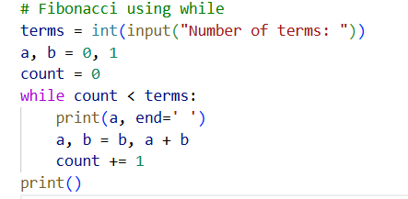
For loop :
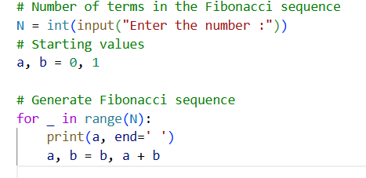
- Output :
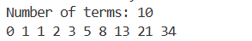

Experiment 6: Finding Square Root (Without Built-in sqrt())
- Aim :
To compute the square root of a positive number using the Newton Raphson iterative method.
- Algorithm / Pseudocode :
- Read n. If n==0 return 0.
- Start guess x = n/2 (or 1).
- Repeat: x_next = 0.5*(x + n/x) until abs(x_next - x) < eps.
- Compare to math.sqrt(n).
- Python Code :
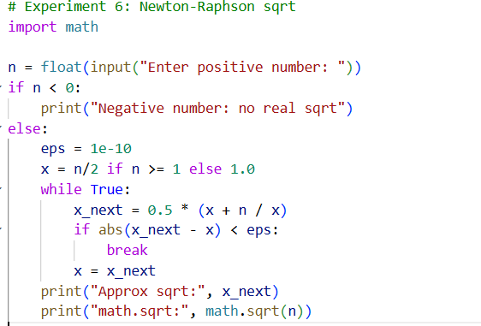
- Output :
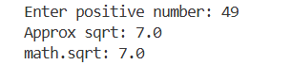

Experiment 7: Generate Prime Numbers & Prime Factors
- Aim :
To generate prime numbers within a given range and compute prime factorization.
- Algorithm / Pseudocode :
- Sieve:
  - Create boolean list is_prime[0..N]=True (0/1 false).
  - For p from 2 to sqrt(N): if is_prime[p] mark multiples false.
  - Collect primes.
- Prime factors:
  - For i=2 while i*i <= n: while n % i == 0: record i, n//=i.
  - If n>1 record n.

- Python Code :
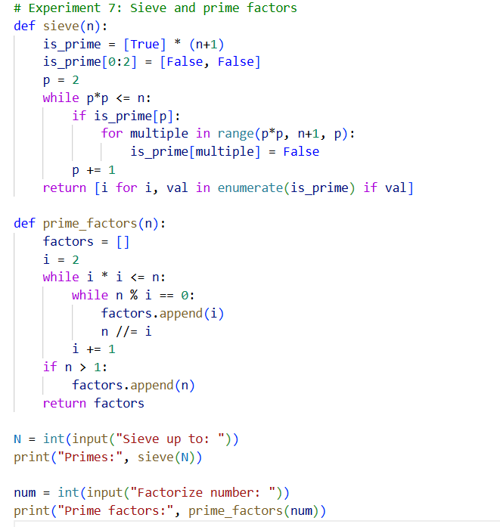
- Output :

Experiment 8: Generating Pseudo-Random Numbers
- Aim :
To generate pseudo-random numbers using Linear Congruential Generator (LCG).
- Algorithm / Pseudocode :
- Choose a, c, m, seed.
- Loop 10 times: seed = (a*seed + c) % m, print seed.
- Python Code :
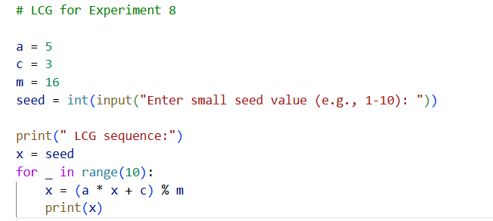
- Output :
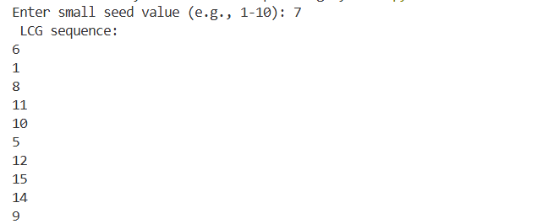

Experiment 9: Raising a Number to a Large Power Fibonacci
- Aim :
To implement efficient exponentiation and Fibonacci computation.
- Algorithm / Pseudocode :
- Input a, b.
- Set result=1.
- While b>0: if b&1: result *= a; a *= a; b >>=1.
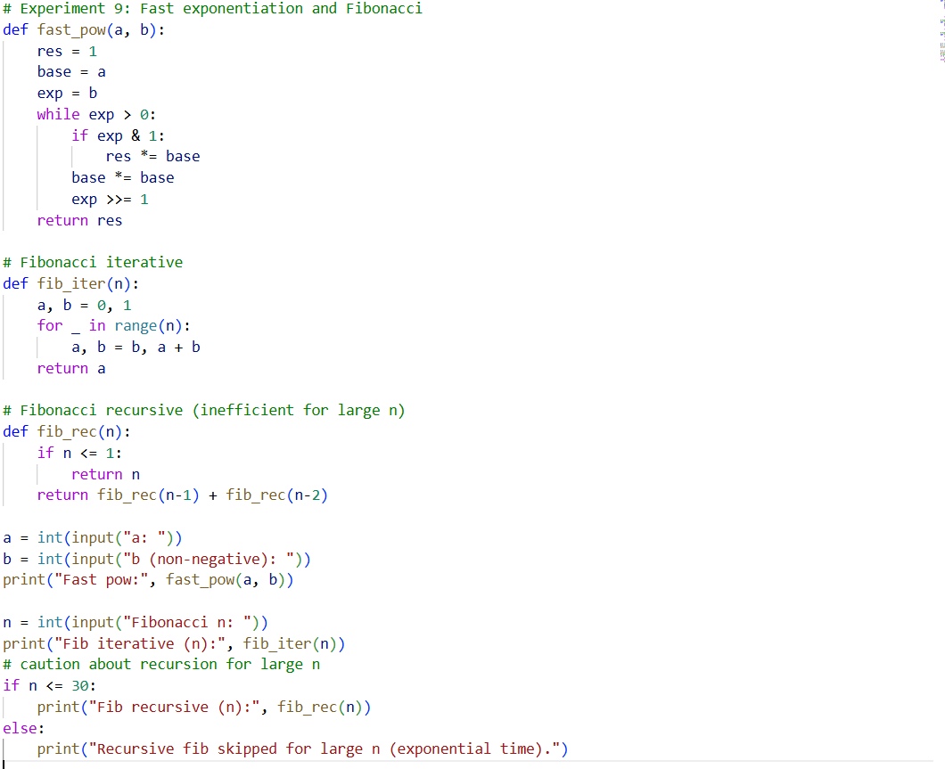
- Python Code :

- Output :
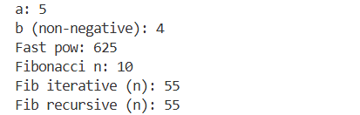

Experiment 10: Array Order Reversal & Counting (Lists)
- Aim :
Reverse an array (list) and count frequency of elements.
- Algorithm / Pseudocode :
- Read list of items.
- Reverse via slicing or reverse().
- Count frequencies using a dict or collections.Counter.
- Python Code :
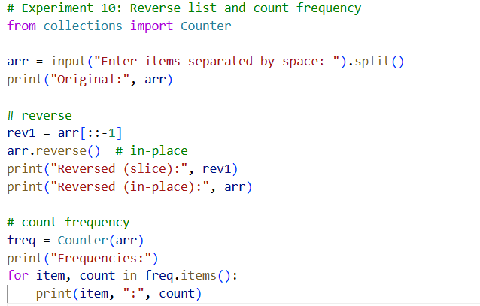

- Output :
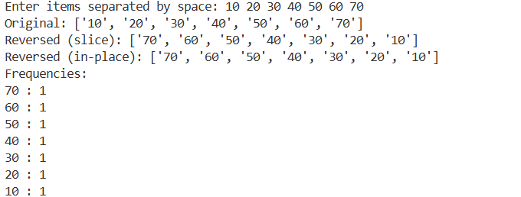
Experiment 11: Finding Maximum Number in a Set
- Aim :
Find maximum element and its index without using built-in max().
- Algorithm / Pseudocode :
- Read list arr.
- Set max_val = arr[0], idx = 0.
- For i from 1..len-1: if arr[i] > max_val: update.
- Python Code :
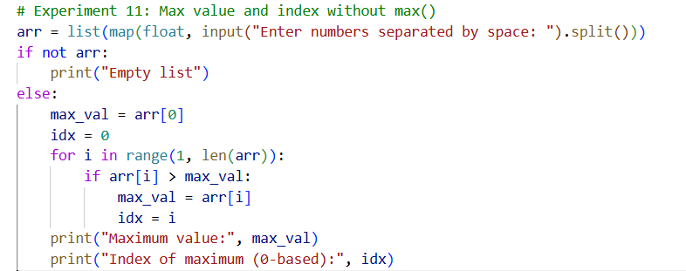
- Output :

Experiment 12: Removal of Duplicates from Ordered Array
- Aim :
Remove duplicates from a sorted list while preserving order.
- Algorithm / Pseudocode :
- Read sorted list.
- Iterate and append to new list only when different from last appended.
- Python Code :
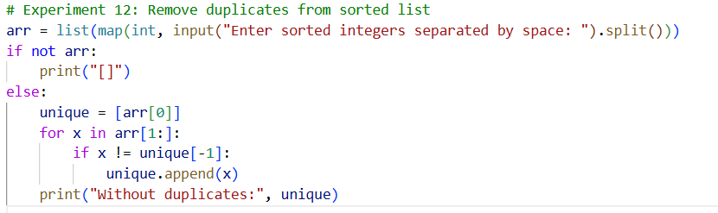
- Output :

Experiment 13: Partitioning an Array (Pivot-based)
- Aim :
Partition an array relative to a pivot (elements < pivot, == pivot, > pivot).
- Algorithm / Pseudocode :
- Read list and pivot p.
- Create three lists: lt, eq, gt. Append elements accordingly.
- Concatenate or return partitions.
- Python Code :
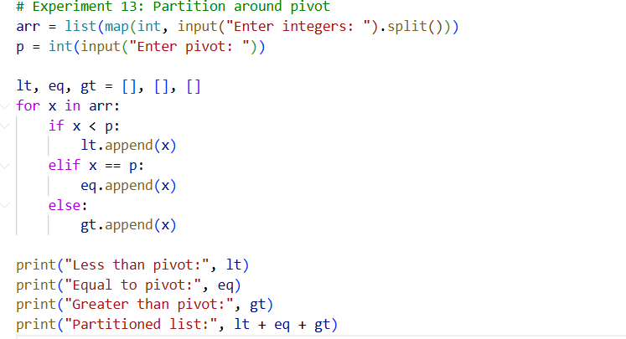
- Output :
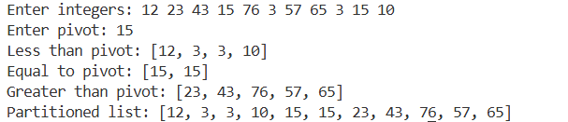

Experiment 14: Finding the Kth Smallest Element & Collections Time Tradeoff
- Aim :
Find kth smallest element and demonstrate list/tuple/set/dict operations and time tradeoffs.
- Algorithm / Pseudocode :
- Part A: Finding the Kth Smallest Element
- Start the program.
- Input the number of elements and store them in a list.
- Input the value of k.
- Sort the list in ascending order.
- The kth smallest element is at index k-1.
- Display the kth smallest element.
- Part B: Demonstrating Time Tradeoffs
- Import the time module.
- Create a list, tuple, set, and dictionary with the same sample data.
- For each structure, measure the time taken for:
- Searching an element (in operation)
- Insertion (not applicable for tuple)
- Deletion (not applicable for tuple)
- Record and display the time taken for each operation.
- Stop.

- Python Code :

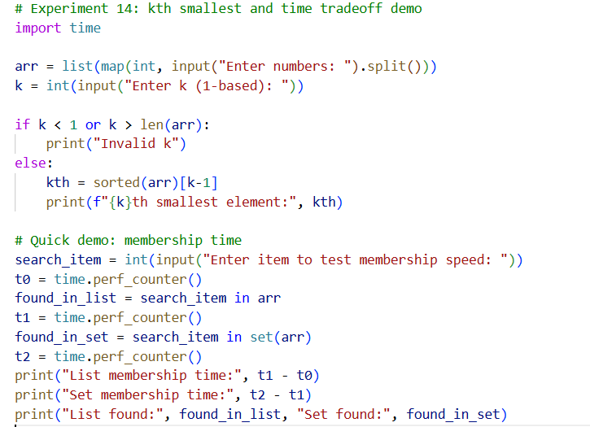
- Output :
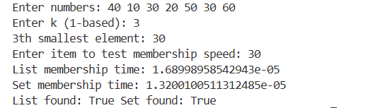

Experiment 15: Grade Calculation Using if-elif-else
- Aim :
To write a Python program that reads a student’s marks (out of 100) and assigns a grade based on the following criteria:
- Algorithm / Pseudocode :
- Start
- Input marks
- If marks ≥ 90 → Grade A
- Else if marks ≥ 80 → Grade B
- Else if marks ≥ 70 → Grade C
- Else if marks ≥ 60 → Grade D
- Else → Grade F
- Print grade
- Stop

- Python Code :
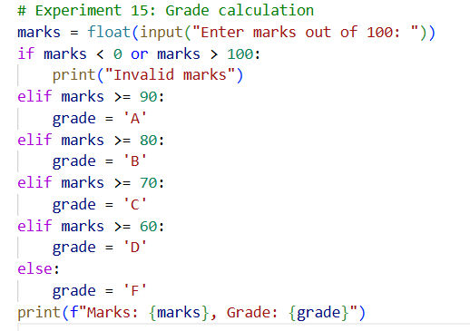
- Output :
